ASSIGNMENT karthikavula76@gmail.com

**Topic: Introduction to Software Development Life Cycle (SDLC)**

**Topic: Exploring SDLC Models**

1.SDLC Overview, Create a one-page info graphic that outlines the SDLC phases (Requirements, Design, Implementation, Testing, Deployment), highlighting the importance of each phase and how they interconnect?

Ans:

The Software Development Life Cycle (SDLC) is a framework used in software engineering to guide the process of developing software applications. It consists of several phases, each with its own importance and role in the overall development process.

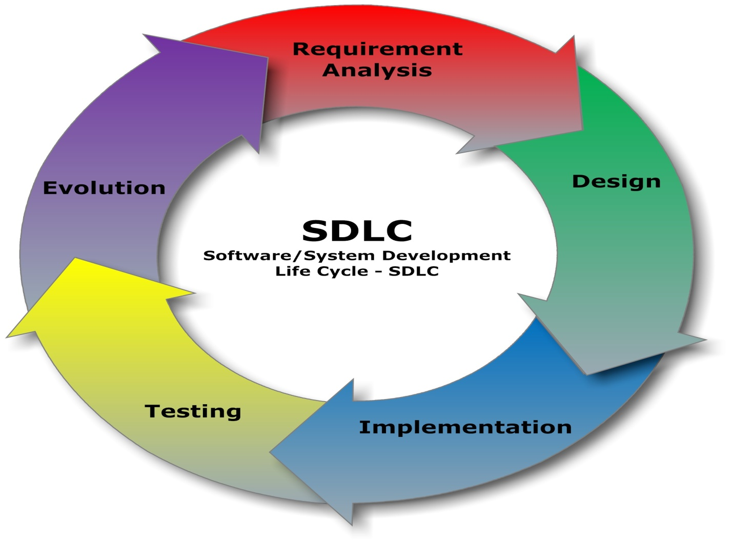

1. Requirements: This phase involves gathering and analyzing the requirements for the software. It's crucial because it lays the foundation for the entire project by determining what the software needs to do and how it will meet the users' needs.

2. Design: In this phase, the system architecture and detailed design are created based on the requirements gathered. It focuses on defining how the software will be structured and how different components will interact with each other.

3. Implementation: This is where the actual coding and development of the software take place. Developers write the code according to the design specifications, turning the conceptual design into a working system.

4. Testing: Once the implementation is complete, the software is tested to ensure it meets the specified requirements and functions correctly. Testing is critical for identifying and fixing any defects or issues before the software is deployed to users.

5. Deployment: In this final phase, the software is deployed to the production environment and made available to users. Deployment involves installing the software, configuring it as necessary, and ensuring it runs smoothly in the production environment.

These phases are interconnected and iterative, meaning that they may be revisited and refined throughout the development process. For example, if issues are discovered during testing, the design and implementation may need to be revised to address them. Similarly, feedback from deployment may inform future iterations of the software

2. Develop a case study analyzing the implementation of SDLC phases in a real-world engineering project. Evaluate how Requirement Gathering, Design, Implementation, Testing, Deployment, and Maintenance contribute to project outcomes.

Ans:

Let's consider a case study of a company developing a new mobile banking application.

1. Requirement Gathering: Initially, the project team conducts extensive interviews and surveys with potential users to understand their needs and expectations from the mobile banking app. They gather requirements related to features, security, user experience, and integration with existing banking systems.

2. Design: Based on the requirements gathered, the team creates a detailed design for the mobile banking app. This includes designing the user interface, defining the backend architecture, and planning for data security measures. The design phase ensures that the app will meet user needs while also being scalable and maintainable.

3. Implementation: With the design in place, developers begin coding the mobile banking app according to the design specifications. They follow coding best practices and adhere to coding standards to ensure the quality and maintainability of the code base. The implementation phase transforms the design into a functional software product.

4. Testing: Once the initial development is complete, the app undergoes rigorous testing to identify and fix any bugs or issues. This includes unit testing, integration testing, and user acceptance testing. Testing ensures that the app functions correctly, meets performance requirements, and provides a seamless user experience.

5. Deployment: After successful testing, the mobile banking app is deployed to production servers and made available to users through app stores. Deployment involves installing the app, configuring servers, and ensuring that security measures are in place to protect user data. The deployment phase marks the transition from development to live operation.

6. Maintenance: Once the app is live, the project enters the maintenance phase. This involves monitoring the app for any issues or performance problems and releasing updates and patches as needed. Maintenance ensures that the app remains functional, secure, and up-to-date with changing user needs and technology advancements.

In this case study, each phase of the SDLC contributes to the successful outcome of the mobile banking app project. Requirement gathering ensures that the app meets user needs, design ensures it's well-structured and scalable, implementation brings the design to life, testing ensures quality and reliability, deployment makes it available to users, and maintenance ensures its ongoing functionality and relevance. By following the SDLC phases systematically, the project team can deliver a high-quality mobile banking app that meets user expectations and business goals.

3. Research and compare SDLC models suitable for engineering projects. Present findings on Waterfall, Agile, Spiral, and V-Model approaches, emphasizing their advantages, disadvantages, and applicability in different engineering contexts?

Ans:

Let's delve into the comparison of different SDLC models:

1. Waterfall Model:

* The classic waterfall model was introduced in the 1970s by Win Royce
* The Waterfall Model was the first Process Model to be introduced
* It is also referred to as a linear-sequential life cycle model
* The waterfall model is a sequential design process, often used in software development processes, in which progress is seen as flowing steadily downwards like a waterfall through the phases of SDLC
* Every stage has to be completed separately at the right time so you cannot jump stages
* Documentation is produced at every stage of a waterfall model to allow people to understand what has been done

Advantages:

* Sequential and easy to understand.
* Well-suited for projects with clearly defined requirements upfront.
* Each phase has specific deliverables, making it easier to track progress.

Disadvantages:

* Limited flexibility for changes once a phase is completed.
* High risk of project failure if requirements are not accurately captured initially.
* Testing occurs only after development is complete, potentially leading to late identification of issues.

Applicability: Waterfall is suitable for projects where requirements are stable and unlikely to change, such as construction projects or hardware development.

2.Agile Model:

* Agile development model is an amalgamation of iterative and incremental process models focusing more on process adaptability and customer satisfaction by rapid delivery of functional software product
* Agile development model breaks the software into small incremental builds
* These builds are provided in iterations
* Each iterations lasts from about one to three weeks
* Every iteration involves cross functional teams working simultaneously on various areas like planning, requirements analysis, design, coding, unit testing, and acceptance testing

Advantages:

* Iterative and flexible, allowing for changes throughout the development process.
* Continuous feedback from stakeholders ensures alignment with business needs.
* Faster time-to-market due to incremental delivery of working software.

Disadvantages:

* Requires active involvement and collaboration from stakeholders, which can be challenging to maintain.
* Less documentation compared to other models, which may lead to difficulties in maintaining consistency and knowledge transfer.
* May not be suitable for projects with strict regulatory or compliance requirements.

Applicability: Agile is suitable for projects where requirements are expected to evolve, such as software development, where rapid adaptation to changing market needs is crucial.

1. Spiral Model:

Advantages:

* Incorporates elements of both waterfall and iterative development, providing flexibility and risk management.
* Emphasizes early identification and mitigation of risks through iterative cycles.
* Allows for progressive refinement of requirements and design based on feedback.

Disadvantages:

* Complex and requires a high level of expertise to implement effectively.
* Can lead to scope creep if risks are not managed effectively.
* Requires extensive documentation and planning, which can increase overhead.

Applicability: Spiral model is suitable for large-scale projects with high levels of uncertainty and risk, such as complex software systems or projects involving cutting-edge technologies.

1. V-Model:

Advantages:

* Emphasizes a systematic approach to testing, ensuring thorough verification and validation of requirements.
* Provides a clear mapping between development phases and corresponding testing activities.
* Suitable for projects with stringent quality and compliance requirements.

Disadvantages:

* Can be rigid and less adaptable to changes in requirements.
* Testing activities may be delayed until later stages, leading to late discovery of defects.
* Requires significant upfront planning and documentation, which may slow down the development process.

Applicability: V-Model is suitable for projects where thorough testing and validation are critical, such as safety-critical systems, medical device development, or government projects with regulatory compliance requirements.

In summary, each SDLC model has its strengths and weaknesses, and the choice of model depends on factors such as project size, complexity, level of uncertainty, and stakeholder requirements. It's essential to evaluate these factors carefully and select the most appropriate model to ensure project success.